Analog Electronic Circuits – Lab 2

*Sricharan Vinoth Kumar*

*Roll No: 2024112022*

Experiment 1:

* Objective:

1. To measure the internal resistance of the given diode at different values of applied voltage.
2. To observe the transient behaviour of the diode at different sinusoidal frequencies.
3. To observe the effect of a capacitor in parallel with a half wave rectifier circuit.

* Components Required:
  + DSO
  + Diode
  + Resistor
  + Capacitor
* Circuit Diagram:

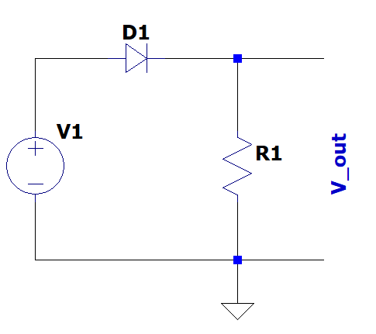

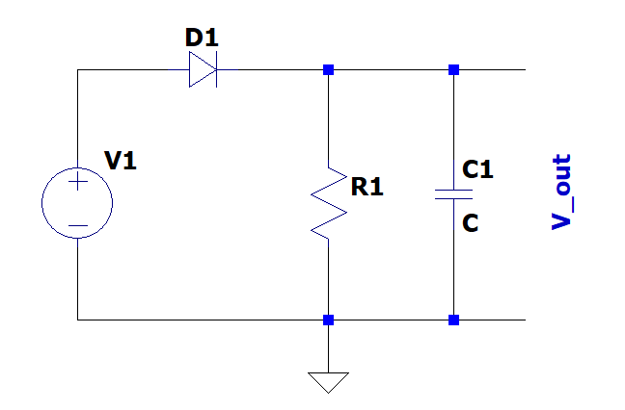

* Procedure:
  + 1:

1. Assemble the circuit given in circuit diagram 1 and apply a Sinusoidal Voltage in V1 and note down the cut-in voltage.
2. Now apply a DC voltage. Measure Vout and using the formula below, calculate the internal resistance at that value of Vin.
3. Repeat for different values of DC Voltages, and tabulate the values obtained.
   * 2:
4. To the same circuit, apply a Sinusoidal voltage of a certain frequency (say 500Hz) at V1.
5. Observe the transient behaviour of the diode in the oscilloscope by connecting its probes across R1.
6. Repeat for different frequencies.
   * 3:
7. Assemble the circuit given in circuit diagram 2 and apply a Sinusoidal voltage of at V1.
8. Connect the probes of the oscilloscope across the capacitor and observe the response obtained.
9. Repeat for another value of capacitance

* Observation:
  + 1:

|  |  |  |  |  |
| --- | --- | --- | --- | --- |
| Vin (V) | Vout (V) | Vcut-in (V) | R (Ω) | Rin (Ω) |
| 0.55 | 0.075 | 0.3375 | 1000 | 1833.333333 |
| 1.8 | 1.175 | 0.3375 | 1000 | 244.6808511 |
| 2 | 1.3625 | 0.3375 | 1000 | 220.1834862 |

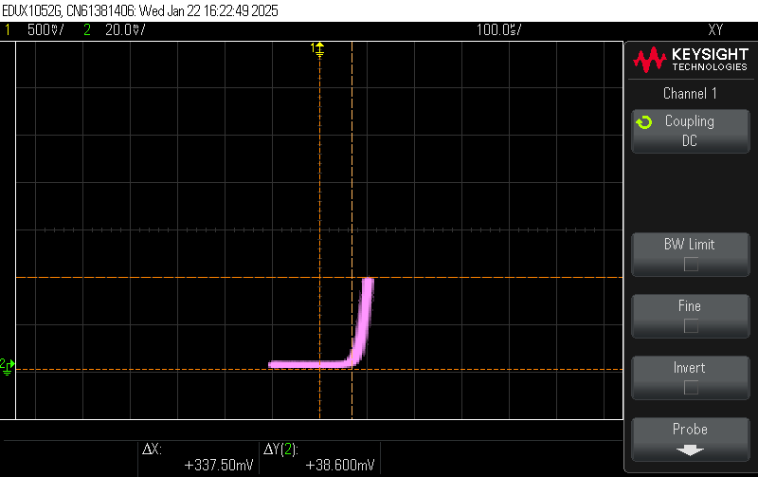

Measurement of Cut-in Voltage

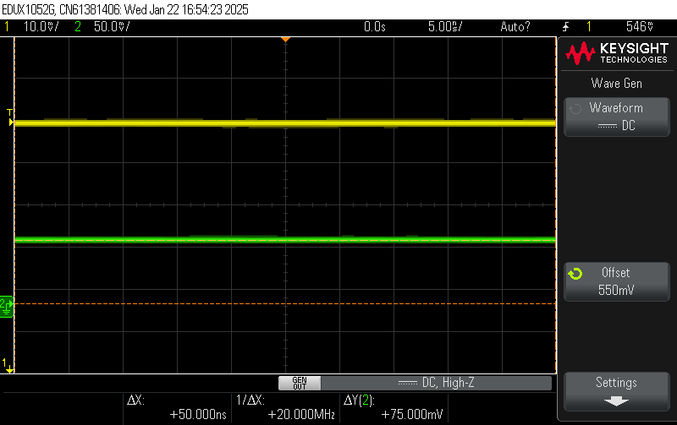

Measurement 1

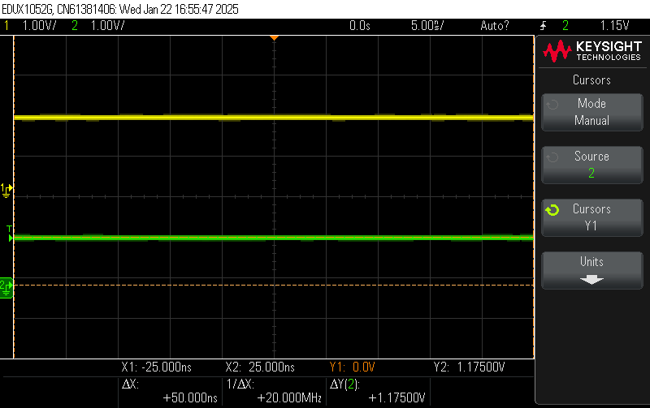

Measurement 2

Measurement 3

* + 2:

Measurement 1: Frequency = 500Hz

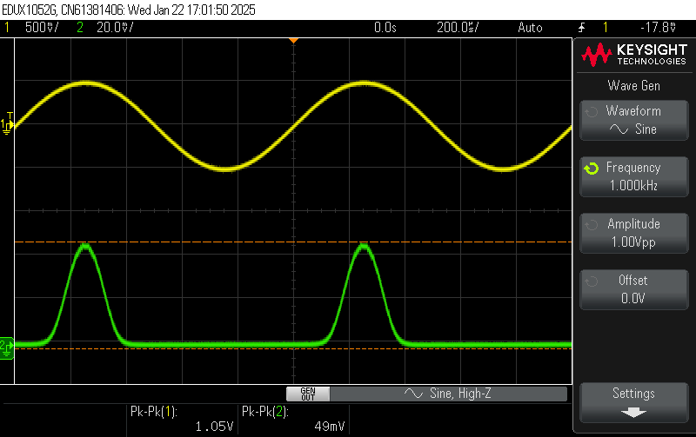

Measurement 2: Frequency = 1kHz

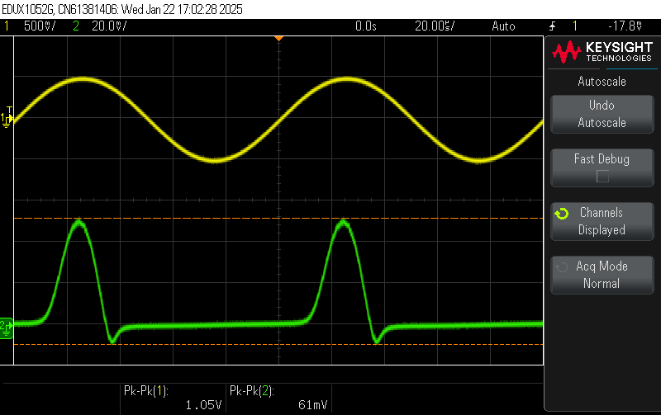

Measurement 3: Frequency = 10kHz

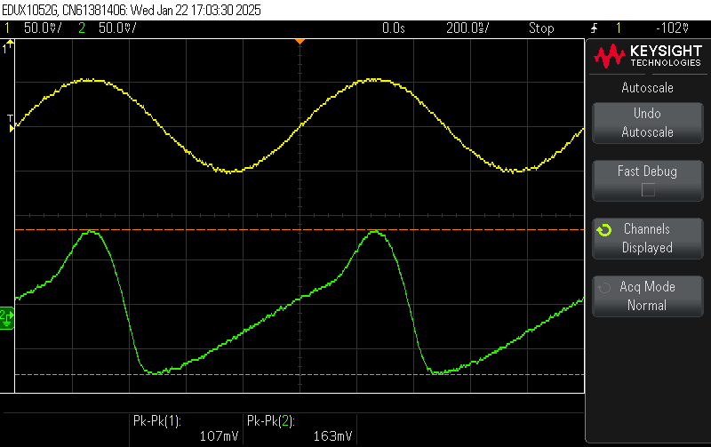

Measurement 4: Frequency = 1MHz

* + 3:

Frequency = 300Hz, Amplitude = 5V

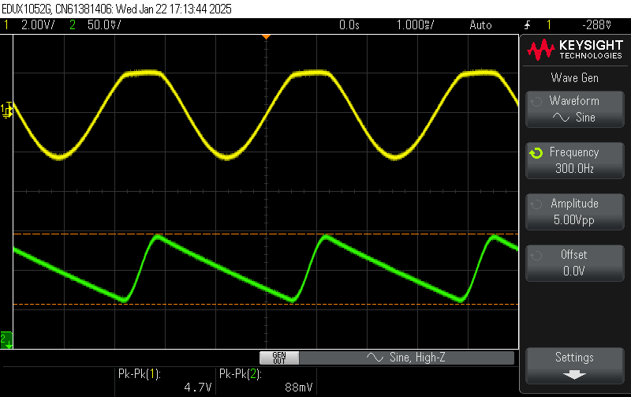

Measurement 1: Capacitance = 47µF. Voltage Drop = 88mV

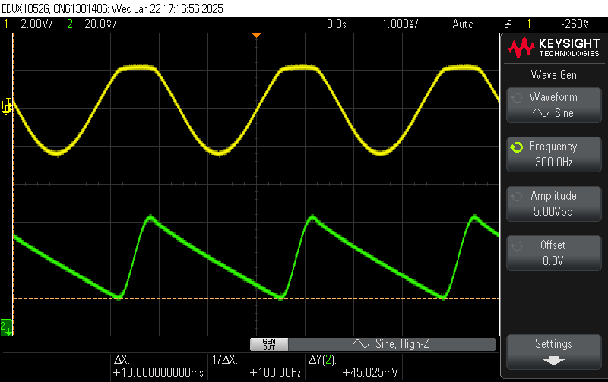

Measurement 2: Capacitance = 100µF. Voltage Drop = 45.025mV

* Result:

1. The internal resistance of the diode has been measured at different applied voltages. It is observed that the internal resistance decreases with increasing voltage.
2. The transient behaviour of the diode has been observed. Increasing the frequency of the sinusoidal voltage further deviates the output response from that of an ideal half wave rectifier, since the dominance of transient behaviour increases.
3. The effect of a capacitor on a half wave rectifier has been observed. Increasing the value of the capacitance lessens the drop in voltage.

Experiment 2:

* Objective:

To observe the behaviour of clipper circuits.

* Components Required:
  + DSO
  + Resistor
  + Diode
  + DC Supply
* Circuit Diagram:

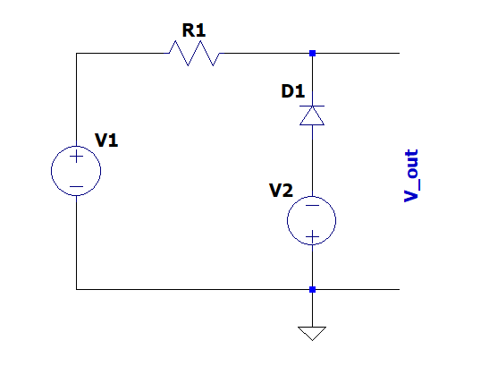

* Procedure:

1. Assemble the circuit as shown above. Use the DC supply for V2. Generate a sinusoidal voltage at V1.
2. Connect the probes of the DSO across the terminals Vout. Set voltage V2 to a value less than the amplitude of V1.
3. Observe the output across Vout and find the cut-in voltage of the diode.
4. Change the voltage in V2 and tabulate the values.
5. Design a similar circuit to clip both halves of the sine wave.

* Observation:

|  |  |  |  |
| --- | --- | --- | --- |
| Amplitude (V) | Vbias (V) | Freq (Hz) | Cut In Voltage (V) |
| 10 | 1.81 | 1000 | - 2.25 |
| 10 | 3.42 | 1000 | -3.86 |

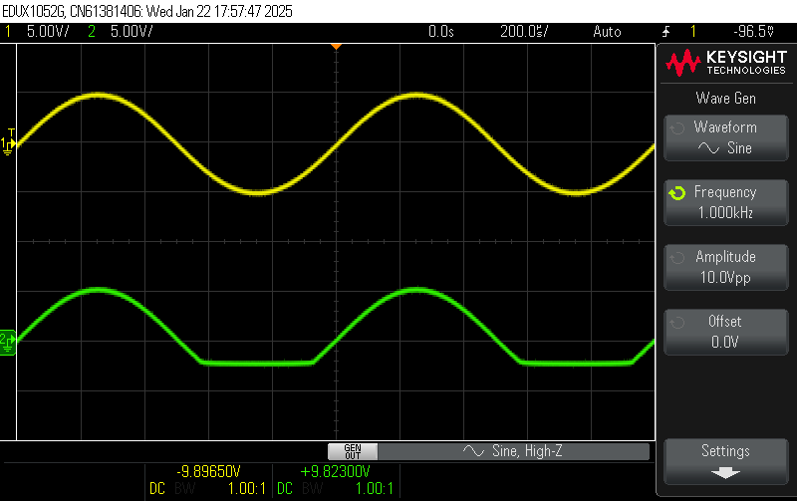

Measurement 1

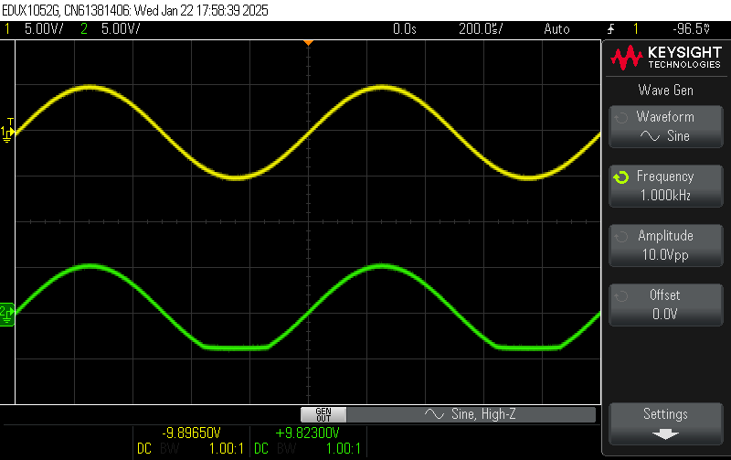

Measurement 2

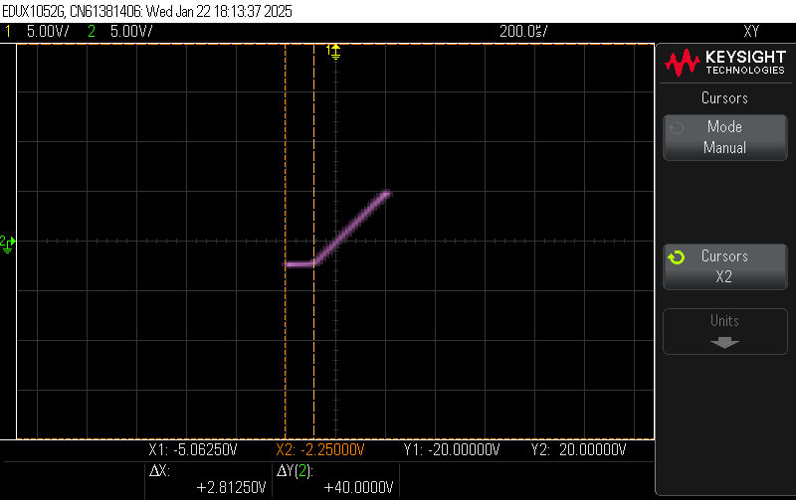

Cut-in Voltage 1

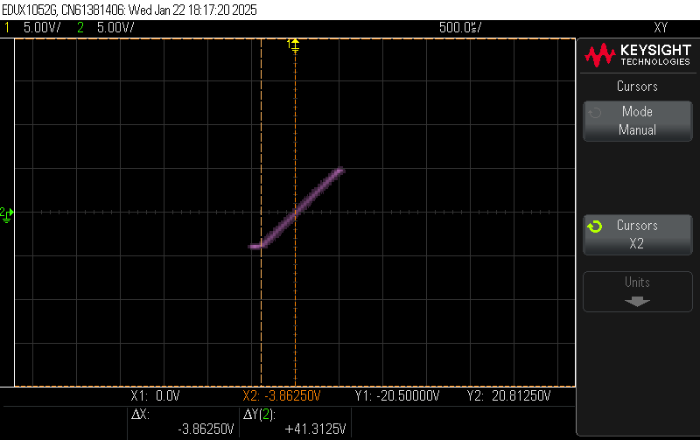

Cut-in Voltage 2

Clipper Circuit For Clipping Both Halves

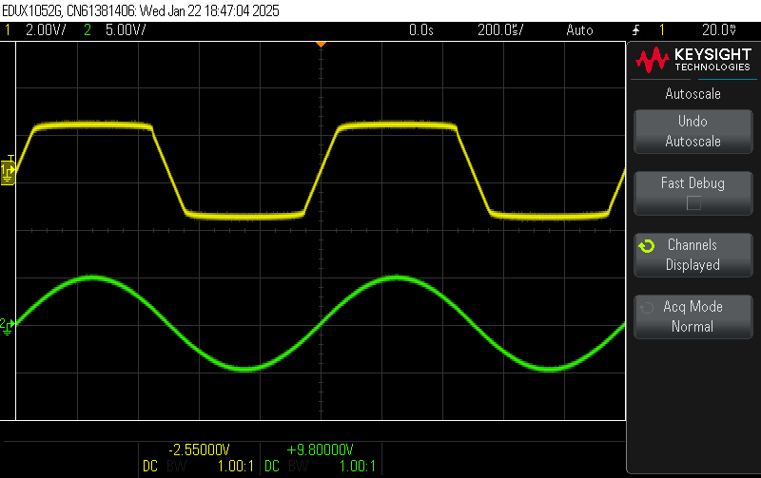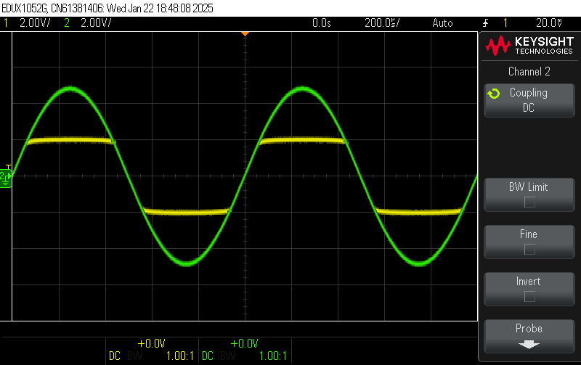

Output of Designed Clipper Circuit

* Result:
  + A clipper circuit has been assembled, and its behaviour has been observed. The voltage at which the clipping occurs decreases with increase in bias voltage (V2).
  + A clipper circuit that clips both halves of the wave has been designed and its behaviour verified.

Experiment 3:

* Objective:

1. To observe the ambient noise using a DSO.
2. To build an Energy Harvester using the noise.

* Components Required:
  + DSO
  + Resistor
  + Capacitor
  + Diode
  + Long Wires (Antenna)
* Circuit Diagram:

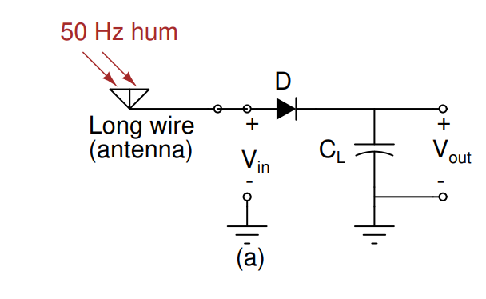

* Procedure:

1. Leave the probes of the DSO free or connect them to long wires to capture the noise in the environment.
2. Assemble the above shown circuit, using the long wires as antennae. Discharge the capacitor.
3. Try to use the noise captured at the antennae to charge the capacitor.
4. Once the voltage across the capacitor reaches approximately 400mV (measure using DSO), disconnect the antennae and observe the voltage drop.
5. Once the voltage reaches 300mV, connect a resistor in parallel to the capacitor.

* Observation:

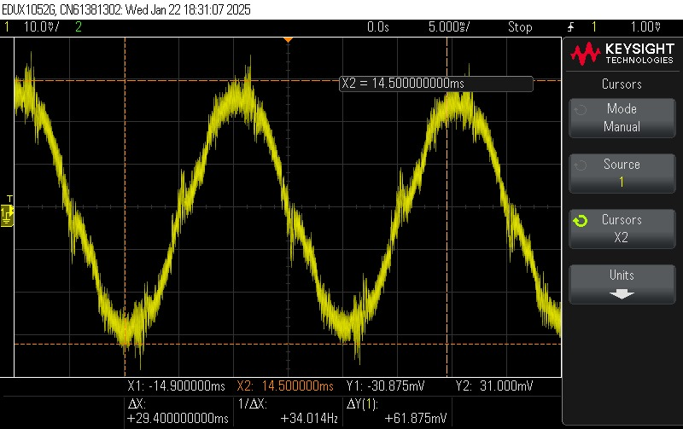

Noise Captured in the DSO.

* Result:

1. The ambient electrical noise was observed on the DSO. The frequency of this noise was 50Hz, which corresponds to the 50Hz frequency of the AC current used by the electrical appliances across the room.
2. Due to the low strength of the noise (about 60mV), no significant amount of energy was stored in the capacitor